Project Documentation

## SkipQ: Sprint3

**Signed Declaration**

I declare that this thesis was composed by myself, that the work contained herein is my own except where explicitly stated otherwise in the text.

Signature: Saira Fatima

Contents

1.1 SkipQ: Sprint3 1

3 Project Description 3

3.1 What is sns service? 3

3.2 What is aws Lmabda? 3

3.3 What is cloud9? 3

3.4 What is aws_cdk? 4

3.5 overview 4

4 Project Motivation 4

5 Project Requirements 5

5.1 Functional Requirements 5

5.2 Non-Functional Requirements 5

6 Detail Design and Architecture 5

6.1 Flow Diagram 5

6.2 Alarm Notification Table Schema 5

7 setup environment 6

7.1 Installations 6

7.2 Steps To Follow 6

7.2.1 Commands 6

8 Project Code Description 6

8.1 InfraStack.py 6

8.1.1 Libraries 6

8.1.2 Code 7

8.2 Constants.py 7

8.2.1 Code 7

8.3 handler.py 7

8.4 Web_health_publisher.py 8

8.4.1 Libraries 8

8.4.2 code 8

8.5 Cloudwatch_defination.py 8

8.6 Lambda_database.py 8

8.7 dynamo_db.py 8

9 SUCCESSFUL RUN 8

10 Difficulties faced 10

10.1 dynamodb read write access 10

10.2 sns notifcation error 10

# Project Description

The project implements a lambda function that receive notification from an SNS and store the data in DynamoDB database on cloud9 using aws_cdk to build cloud infrastructure with programming.

## What is sns service?

Amazon Simple Notification Service (Amazon SNS) is a fully managed messaging service for both application-to-application (A2A) and application-to-person (A2P) communication.

The A2A pub/sub functionality provides topics for high-throughput, push-based, many-to-many messaging between distributed systems, microservices, and event-driven serverless applications. Using Amazon SNS topics, your publisher systems can fanout messages to a large number of subscriber systems including Amazon SQS queues, AWS Lambda functions and HTTPS endpoints, for parallel processing, and Amazon Kinesis Data Firehose. The A2P functionality enables you to send messages to users at scale via SMS, mobile push, and email.

[[Reference]](https://aws.amazon.com/sns/?whats-new-cards.sort-by=item.additionalFields.postDateTime&whats-new-cards.sort-order=desc) [[Documentation]](https://boto3.amazonaws.com/v1/documentation/api/latest/reference/services/sns.html)

## What is aws Lmabda?

AWS Lambda is a serverless, event-driven compute service that lets you run code for virtually any type of application or backend service without provisioning or managing servers. You can trigger Lambda from over 200 AWS services and software as a service (SaaS) application, and only pay for what you use.

[[Reference]](https://aws.amazon.com/lambda/) [[Documentation]](https://docs.aws.amazon.com/cdk/api/latest/python/aws_cdk.aws_lambda.html)

## What is cloud9?

AWS Cloud9 is a cloud-based integrated development environment (IDE) that lets you write, run, and debug your code with just a browser. It includes a code editor, debugger, and terminal. Cloud9 comes prepackaged with essential tools for popular programming languages, including JavaScript, Python, PHP, and more, so you don’t need to install files or configure your development machine to start new projects. Since your Cloud9 IDE is cloud-based, you can work on your projects from your office, home, or anywhere using an internet-connected machine. Cloud9 also provides a seamless experience for developing serverless applications enabling you to easily define resources, debug, and switch between local and remote execution of serverless applications. With Cloud9, you can quickly share your development environment with your team, enabling you to pair program and track each other's inputs in real time.

[[Reference]](https://aws.amazon.com/cloud9/)

## What is aws_cdk?

The AWS Cloud Development Kit (AWS CDK) is an open-source software development framework to define your cloud application resources using familiar programming languages.

[[Reference]](https://aws.amazon.com/cdk/) [[Documentation]](https://docs.aws.amazon.com/cdk/api/latest/python/index.html)

## overview

A lambda function has been written to monitor Latencies and Availabilities of URLs passed in URL array to it in Sprint one. Cloud watch matrices has been created based on latency and availability values for each URL and alarms has been set on these metrices for specific Threshold values. For each alarm sns topic has been created that sends notification to a lambda function with the payload of message when alarm exceed threshold value. This lambda function has access to DynamoDB to write the attributes of message received in sns notifications. All constant values has been defined in separate file constants.py and modular approach has been used to implement above functionality

# Project Motivation

Infrastructure as code has quickly become a go-to process to automatically provision and manage cloud resources. With increasing sophistication, engineers and DevOps teams are codifying infrastructure for greater application flexibility and functionality, with a single-source language across an organization.

IT teams have two AWS-native options for infrastructure as code -- AWS CloudFormation and the AWS Cloud Development Kit (CDK). CloudFormation templates were AWS' first foray into cloud-based infrastructure as code, and while still useful, CloudFormation has clear weaknesses. More specifically, it doesn't offer built-in logic capabilities and has a steep learning curve.

The AWS CDK, an open-source software development framework to define cloud infrastructure, addresses these weaknesses. The AWS CDK supports popular programming languages, which developers can use to build, automate and manage infrastructure based on an imperative approach. Finally, developers can provision these commands through CloudFormation.

As an extensible, open software development framework, the AWS CDK features integrated development environment (IDE) capabilities. As of publication, the AWS CDK supports TypeScript, JavaScript, Python, Java and C#/.Net. In this article, we'll compare the AWS CDK vs. CloudFormation, including their key features, the role of constructs in building application stacks and the benefits of using a common language for AWS-native infrastructure as code.

# Project Requirements

## Functional Requirements

* Project must be implemented on Cloud 9
* Project must be implemented in python
* Cloud infrastructure must be created programmatically
* Project must be implemented using Lambda function from awd_cdk
* Lambda function must return status of url passed
* Lambda function must run every 5 minute to monitor website
* Create metrics on cloud watch for each latency and availability data point for each url
* Set and alarm on CloudWatch metrics
* Enable sns notification service on Lambda
* Lambda must write the sns event timestamp and message in DynamoDB

## Non-Functional Requirements

* Comments must be added in the code
* Code must be structured well
* Modular approach should be used
* Unnecessary global variables must not be used
* Best practices must be followed

# Detail Design and Architecture

## **Flow Diagram**

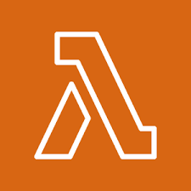  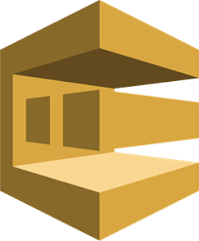  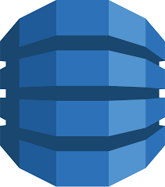

1. Lambda sent metric data to Cloud Watch
2. Sns take message from Cloud watch if Alarm triggers
3. Sns send notification to lambda with message as a payload
4. Lambda save message in DynamoDB

## **Alarm Notification Table Schema**

|  |  |
| --- | --- |
| Time stamp | message |

# setup environment

## Installations

As this project use cloud9 to create our cloud infrastructure. It has everything pre-installed so there is no need to install anything on local machine

## Steps To Follow

* Login to AWS Management Console[[Login]](https://us-east-2.console.aws.amazon.com/console/home?region=us-east-2)
* Create an instance in Cloud9
* Set python 3 in bashrc file as python alias
* Start virtual environment
* Install requirements with requirements.txt
* Create cloud template
* Deploy

### Commands

* To open bashrc file

*vim ~/.bashrc*

Add this code in end

*alias python="/usr/bin/python3"*

* To start virtual environment

*source .venv/bin/activate*

* install requirements

*pip install -r requirements.txt*

* Synthesize

*cdk synth*

* Deploy

*cdk deploy*

# Project Code Description

## InfraStack.py

### Libraries

Cdk libraries has been used to create cloud infrastructure which includes

* Aws_lambda: to create lambda function
* Aws_events: to schedule lambda function to run periodically every 5 minute
* Aws_sns: to send notifications to lambda with payload
* constants: a file that define all constant values in project
* alarm_defination: a file implements alarm creation function
* boto3: a library to write metric on cloud watch

from aws_cdk import core as cdk

from aws_cdk import aws_iam, aws_events, aws_events_targets, core, aws_sns

from aws_cdk import aws_lambda as lambda_

from lambda_b import constants, alarm_defination

import boto3

### Code

Create and iam role to access aws services. Then create a lambda function as a test function. To create lambda function 3 arguments are required

* ID: Unique ID for each lambda function
* Handler: the function that lambda is going to run
* Role: iam role to give lambda access to services

Schedule_lambda is a function that schedule lambda to run peroodically every 5 minute. It takes 4 input arguments

* Event name: to specify event (defined in constants file)
* Target: lambda function we want to schedule
* Duration: Scheduling duration (5 minutes in this case)
* Event Description

Create alarm is a function defined in alarm_defination to create alarms

the function schedule_lambda schedule lambda to run every 5 minute

The function create_role creates iam role for user. To make lambda able to receive notification we have to set sns Service principal. We need to set policies to get access to dynamodb, cloudwatch and sns

create_lambda creates a lambda function

## Constants.py

### Code

This file defines all constant values in the project

## handler.py

This file defines a hello world lambda function for testing

## Web_health_publisher.py

In this file URLs are being monitored one by one to check their latency and availability and the status is written to cloud watch in form of metrics

### Libraries

The file uses following libraries

* Urllib: to check status of urls
* cloudWatch_defination: file that contain cloud watch metric creation functions

import urllib3

import constants

from cloudWatch_defination import cloudWatchMetrics

### code

health_web is a function that call monitor (url) function to get url status and write the status values in cloud watch metrices.

## Cloudwatch_defination.py

This file creates cloud watch metrics using boto3 client. CloudwatchMetric.create_metric is the function which is creating cloud watch metrics for us actually

## Lambda_database.py

this file implements the function that access dynamo db and write timestamp and message from sns notification

## dynamo_db.py

this file creates a table for user if it is not in databse or insert timestamp and message value in table if it

# SUCCESSFUL RUN

DATABASE

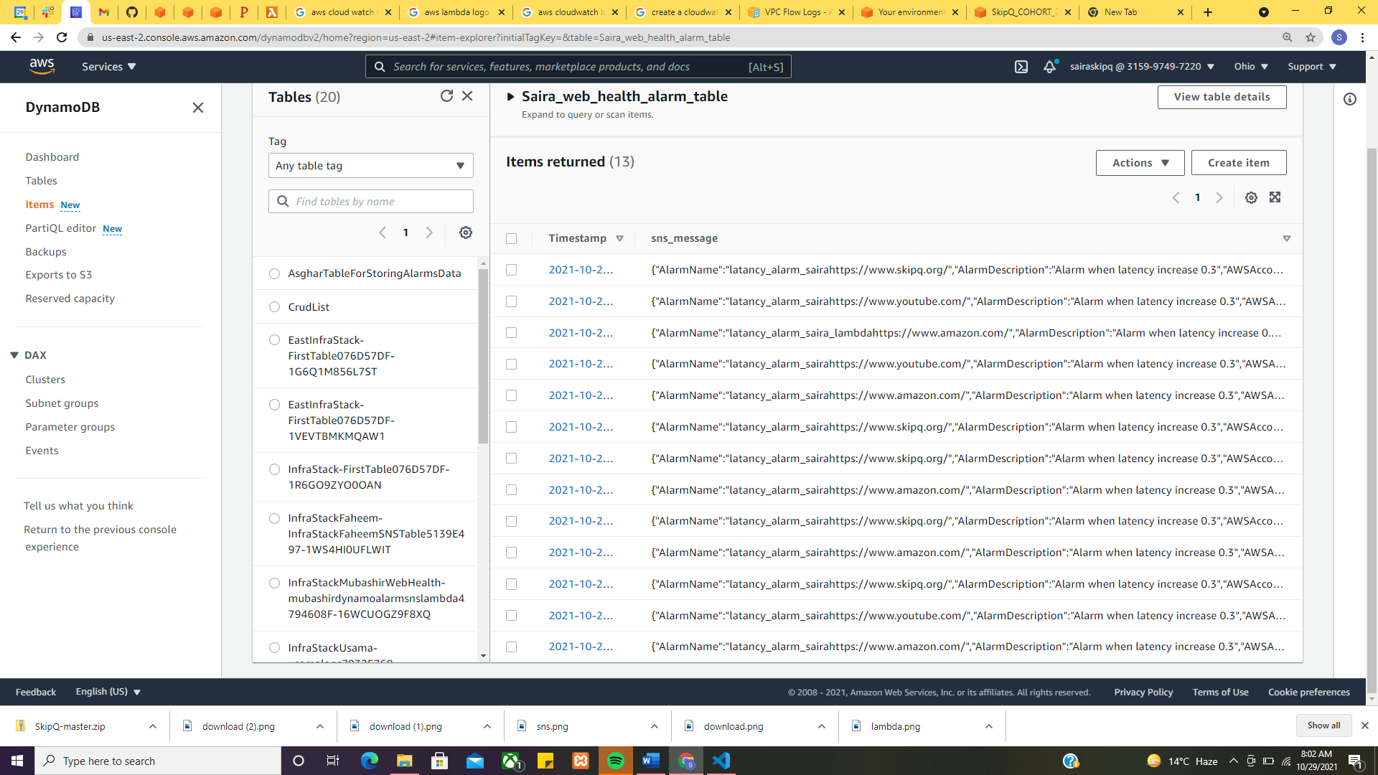

Monitor lambda which has been invoked on sns notifications

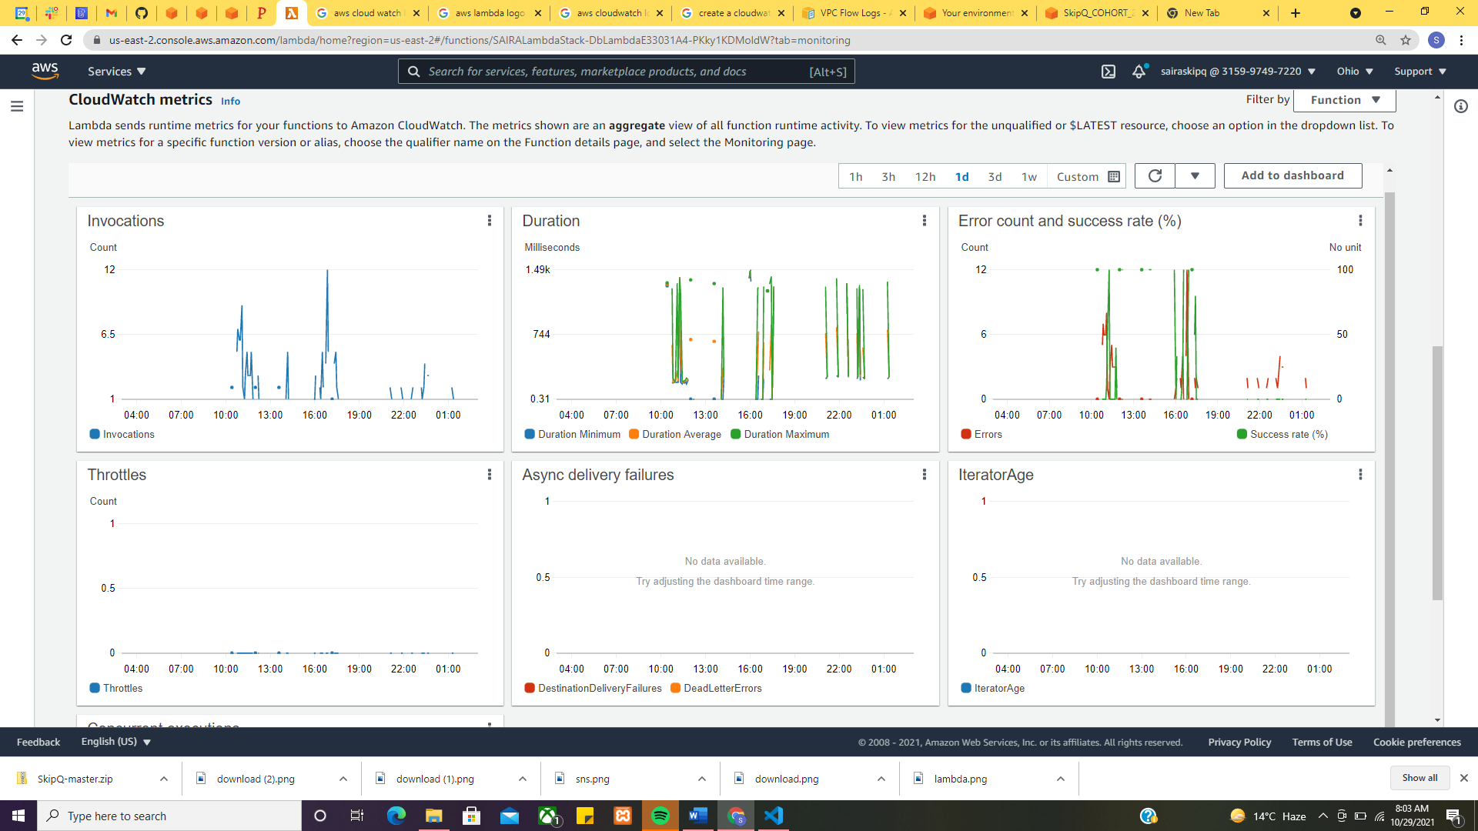

cloudwatch alarm history

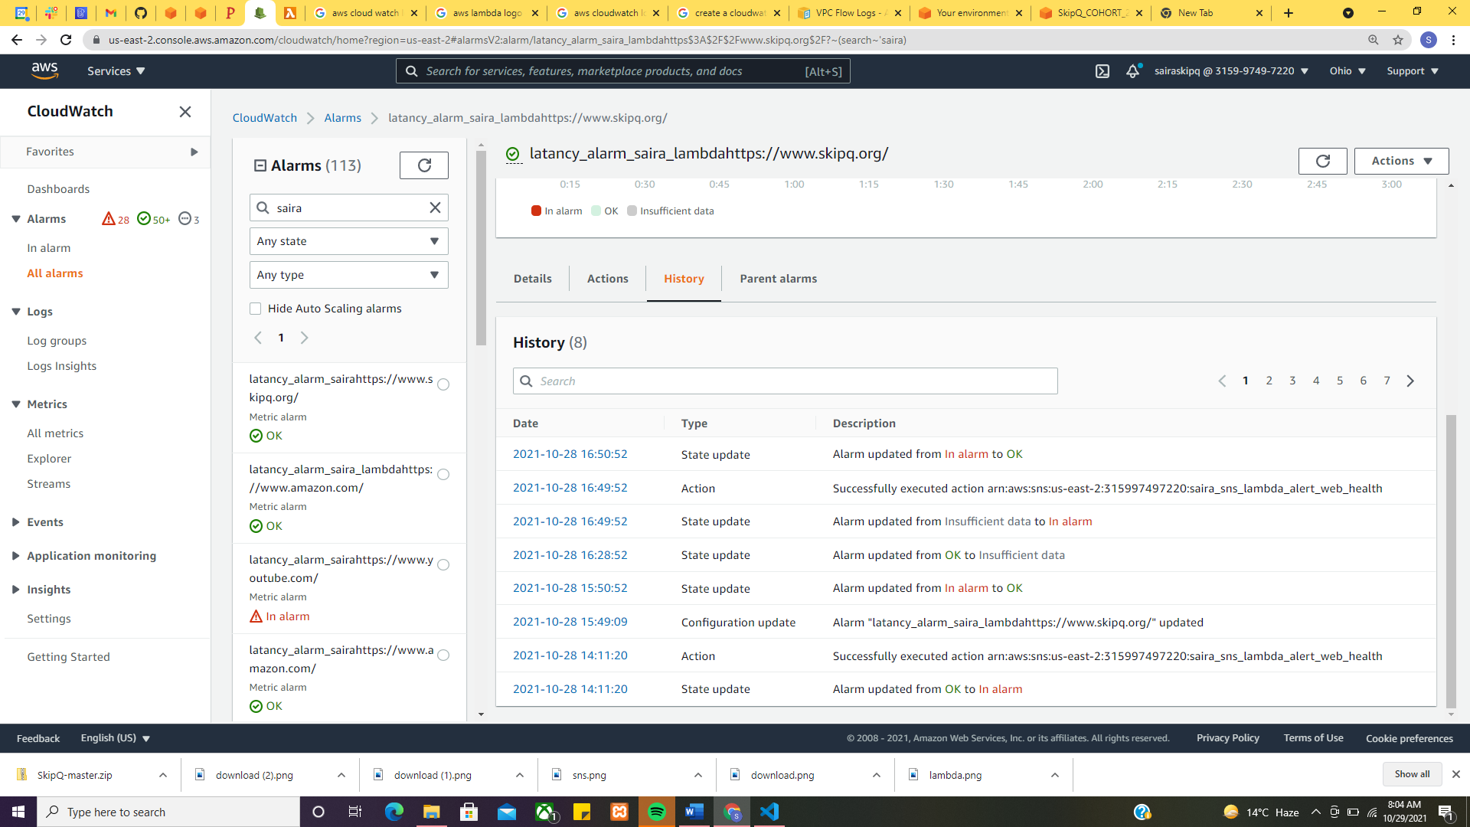

# Difficulties faced

## dynamodb read write access

I was having access denied issue from dynamo db read write. I solved the issue by adding dynamodb full access policy in create role function

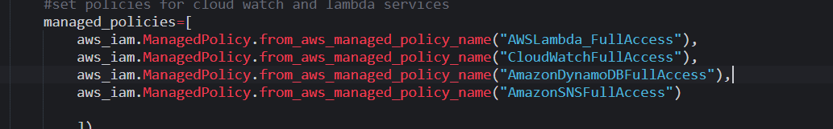

## ****sns notifcation error****

lambda was unable to receive notifications from sns. I solved this issue by adding ServicePrinciapl for sns in role.

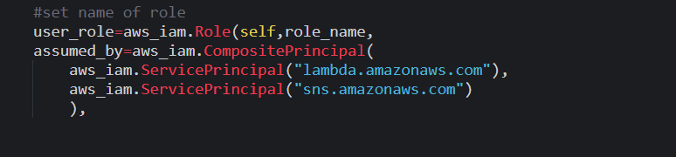

References

<https://aws.amazon.com/cdk/>

<https://aws.amazon.com/cloud9/>

<https://aws.amazon.com/lambda/>

<https://aws.amazon.com/sns/?whats-new-cards.sort-by=item.additionalFields.postDateTime&whats-new-cards.sort-order=desc>